**About Your Massage Therapist**

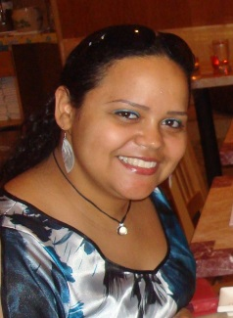Yobelin "Yo" Fernandez earned a Bachelor's Degree in Mathematics in 2002 and taught High School Math for one year. She decided it was not what she wanted to do with her life and transitioned into the business world, working in an administrative capacity at a small boutique modeling agency in New York City for several years.

In 2006, she decided to give in to her true passion and enrolled at the Swedish Institute to begin her journey towards a career in Massage Therapy. She graduated in 2008 with a solid foundation in several body sciences and extensive knowledge of different types of both Western and Eastern massage. Since then, she has traveled to Thailand, where she studied Traditional Thai Massage at the Wat Po temple in Bangkok.

Yo continues to study, learn and research different techniques so that she can bring each client the individual help they need and deserve. She is an active member of the American Massage Therapy Association (AMTA).

You can reach Yobelin on her mobile at 917-696-5728 or via email at yo@yossage.com

**Home** 